These are the fields that the you will fill out (* indicates a required answer)
Your Identity
Let’s start with the basics. This is the public-facing identity visitors will see on the card.

Brand, Organization, or Project * For creators this can be a channel, podcast, ministry, author name, or public identity.
Click or tap here to enter text.
What kind of card is this? This helps us show the right prompts and gives the factory better context. This is a pulldown
Select Card Type
Choose an item.
Short tagline or introduction Example: Texas history, storytelling, and immersive digital media.
Click or tap here to enter text.
Field, niche, or subject area * Examples: local history, real estate, ministry, ranching, education, publishing.
Click or tap here to enter text.
Main website or profile link *
Click or tap here to enter text.
Optional Location
Street address Click or tap here to enter text.
Company Address - Line 2 Click or tap here to enter text.
City Click or tap here to enter text.
State Click or tap here to enter text.
ZIP Click or tap here to enter text.
Service area or audience region Example: Texas, nationwide, online only, San Antonio area.
Click or tap here to enter text.
Public Contact
Your Name *
Click or tap here to enter text.
What should people call your role? Examples: Founder, Host, Pastor, Author, Historian, Consultant.
Click or tap here to enter text.
Public contact email *
Click or tap here to enter text.
Administrative / purchase email Used for account or delivery notices; it can be different from the public email.
Public phone number
Click or tap here to enter text.
Mobile Phone
Click or tap here to enter text.
Availability or business hours
Click or tap here to enter text.
Plan Name
Click or tap here to enter text.
Card Look & Literary Persona
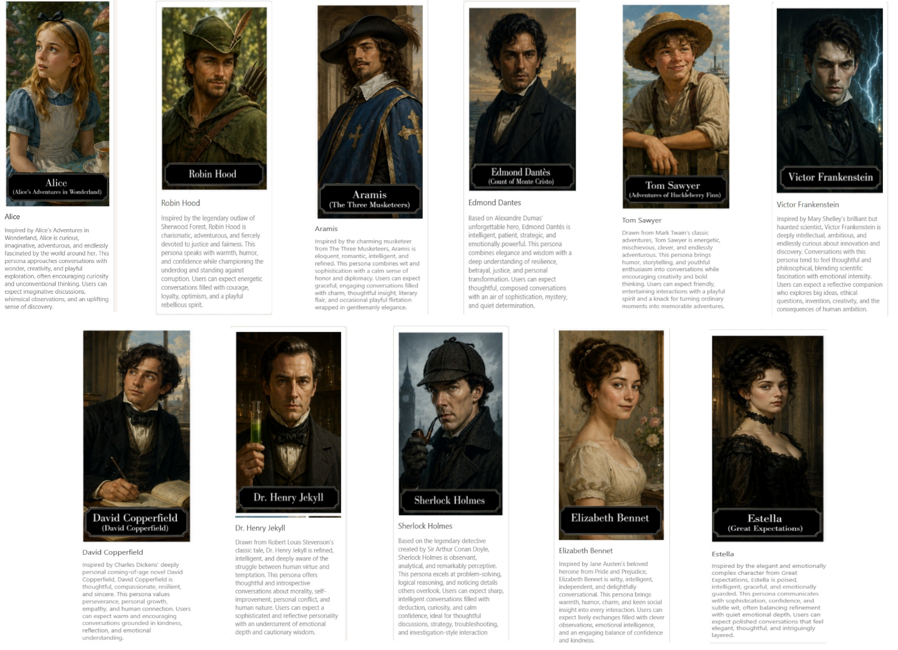
Choose the literary personality for your card *Select Persona (Initial list for alpha testing)
Choose an item.
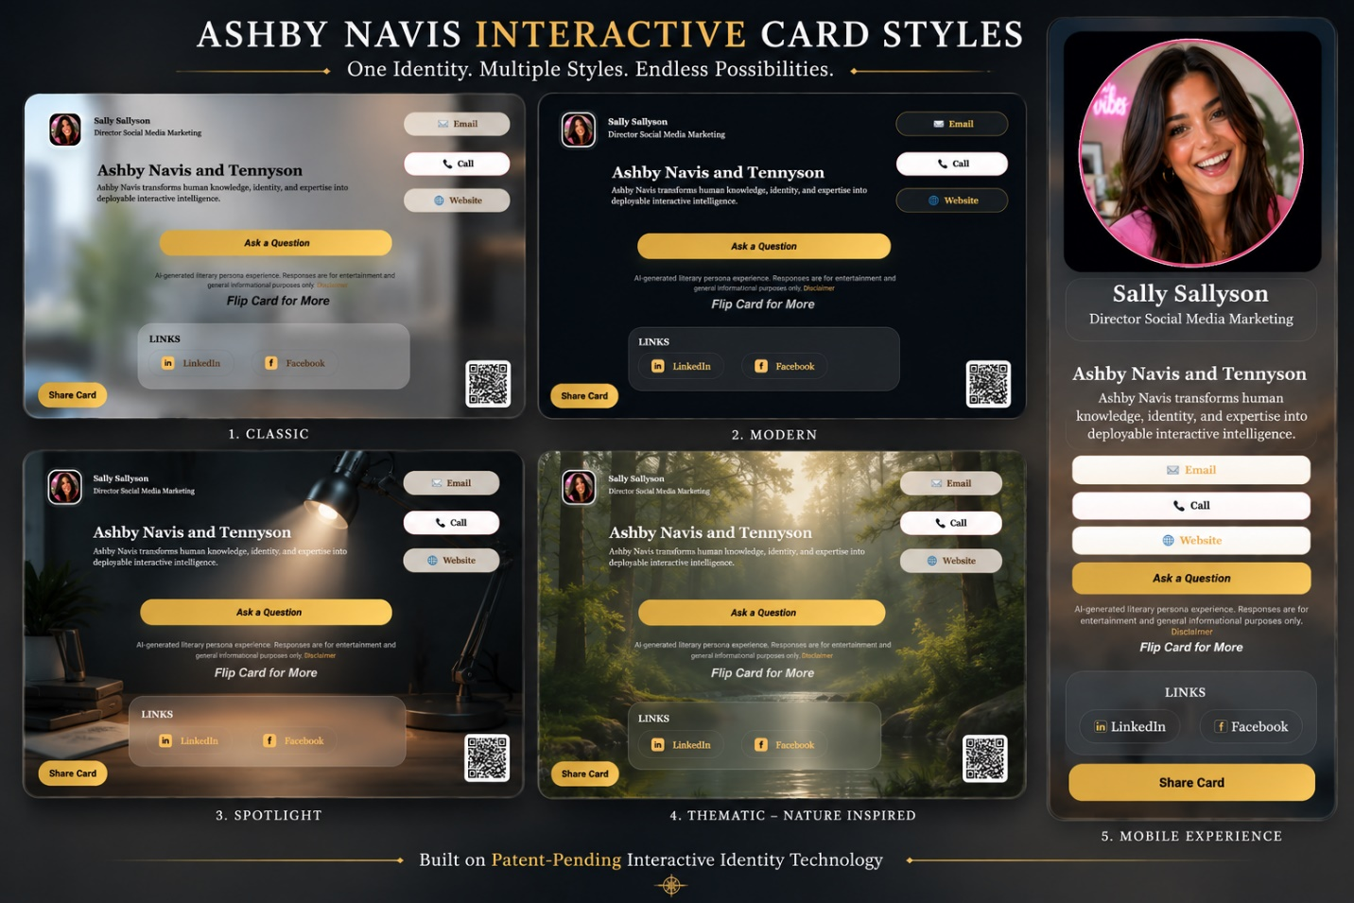

Choose your card style *Select Business Card Style – 4 types see the pulldown
Choose an item.
Spotlight is the creator/media-forward card style with a larger headshot area on the front and the action buttons grouped to the side. The back of the card remains the standard information panel.
Overall communication style *Select Brand Voice
Choose an item.
Conversation tone *Select Tone
Choose an item.
What would you like visitors to do? *Select Preferred Call To Action
Choose an item.
Booking / appointment URL
Click or tap here to enter text.
Social & Media Links
LinkedIn URL
Click or tap here to enter text.
Facebook URL
Click or tap here to enter text.
Instagram URL
Click or tap here to enter text.
X / Twitter URL
Click or tap here to enter text.
YouTube URL
Click or tap here to enter text.
TikTok URL
Click or tap here to enter text.
Pinterest URL
Click or tap here to enter text.

Twitch URL
Click or tap here to enter text.
Etsy URL
Click or tap here to enter text.
Snapchat URL
Click or tap here to enter text.
Products Optional. Add up to three products for the knowledge payload. These do not display on the card front.
Product 1 Name
Click or tap here to enter text.
Product 1 Description
Click or tap here to enter text.
Product 1 Link
Click or tap here to enter text.
Product 2 Name
Click or tap here to enter text.
Product 2 Description
Click or tap here to enter text.
Product 2 Link
Click or tap here to enter text.
Product 3 Name
Click or tap here to enter text.
Product 3 Description
Click or tap here to enter text.
Product 3 Link
Click or tap here to enter text.
Upload headshot or profile image (optional)

Your Story
These answers give the interactive card something human to talk about. Short, natural answers are fine.
What do you help people with? * Example: I help small businesses explain their services clearly, or I help listeners discover overlooked Texas history.
Click or tap here to enter text.
Who do you most want to reach? * Examples: customers, readers, students, church members, fans, business clients, or the general public.
Click or tap here to enter text.
Personality & Knowledge
Now add the background information that helps the persona sound useful, accurate, and personal.
Tell visitors about yourself A short bio, background, or personal introduction.
Click or tap here to enter text.
What are you trying to accomplish? Mission, purpose, ministry focus, creative goal, or business vision.
Click or tap here to enter text.
Describe your work, organization, or project * This can describe a company, podcast, ministry, author platform, channel, project, or personal brand.
Click or tap here to enter text.
What should the card be able to talk about? * Summarize services, books, podcasts, classes, topics, products, or areas of expertise.
Click or tap here to enter text.
Common questions visitors might ask Enter one question or topic per line.
Click or tap here to enter text.
Returns / refund policy if relevant Optional
Click or tap here to enter text.
Shipping / delivery policy if relevant Optional
Click or tap here to enter text.
Support or response hours
Click or tap here to enter text.
Additional notes for the persona Optional
Click or tap here to enter text.

